# iOS 13 Beta Notes

* “[Everything is Too Hard to Use, with Asurion CEO Tony Detter](https://podcasts.apple.com/us/podcast/the-vergecast/id430333725?i=1000444584418)” | *The Verge*

“The most powerful device in human history.”

* [WWDC 2011 Keynote](https://youtu.be/LPMjUtfQPks)
* [Vergecast: Jony Ive leaving Apple and public betas arriving - The Verge](https://www.theverge.com/2019/6/28/19102536/vergecast-podcast-360-jony-ive-leaving-apple-ios13-ipados-macos-catalina-public-beta)
* [iOS 13 Preview - Features](https://www.apple.com/ios/ios-13-preview/features/)
* [Vergecast: Jony Ive leaving Apple and public betas arriving](https://www.theverge.com/2019/6/28/19102536/vergecast-podcast-360-jony-ive-leaving-apple-ios13-ipados-macos-catalina-public-beta) *The Verge*
* [Every new feature so far in iOS 13 public beta, demonstrated](https://youtu.be/vDiQsI18Zk4) | *9to5Mac*
* [Listen to music, movies on two pairs of AirPods with iOS 13 Audio Sharing](https://www.cultofmac.com/638568/how-to-use-ios-13-audio-sharing/)

Audio Sharing doesn’t work with all devices, or all of Apple’s wireless headphones. You can use any AirPods (first and second generations), but the only officially compatible Beats headphones are the [PowerBeats Pro](https://www.cultofmac.com/628390/are-the-powerbeats-pro-better-than-airpods-review/) .

* [PSA: iOS 13 bug allows easy access to all of your passwords - 9to5Mac](https://9to5mac.com/2019/07/15/ios-13-password-bug/)
* Maps: What's New in iOS 13
* iPhone OS 4 renamed iOS 4, launching June 21 with 1500 new features
* [iOS 7 review: a new look or a new beginning?](https://www.theverge.com/2013/9/18/4741724/ios-7-review) | *The Verge*
* [Apple announces iOS 7, 'biggest change' since the introduction of the iPhone, coming this fall](https://www.theverge.com/2013/6/10/4407630/apple-announces-ios-7) | *The Verge*
* [It's Not About New Icons: What Jony Ive Needs to Do for Apple's iOS](https://www.wired.com/2013/05/what-jony-ive-needs-to-do-for-apple/) | *WIRED*
* [Profound Revelations in iOS 12](https://extratone.com/siri-shortcuts-ios12-review) | *Extratone*
* [iOS 13: How to automatically close Safari tabs](https://www.macworld.com/article/3408737/ios-13-how-to-automatically-close-safari-tabs.html) | *Macworld*
* [iOS 13: iPhone and iPad users warned against installing new Apple software even though it is available to download](https://www.independent.co.uk/life-style/gadgets-and-tech/news/ios-13-iphone-ipad-software-update-download-now-how-to-warning-a8998491.html) | *The Independent*
* [iOS 13 will fix the FaceTime eye contact problem](https://www.theverge.com/2019/7/3/20680681/ios-13-beta-3-facetime-attention-correction-eye-contact) | *The Verge*
* [Latest iOS beta prompts you to unsubscribe when uninstalling apps with paid subs](https://www.theverge.com/2019/6/18/18683357/apple-ios-13-beta-2-app-uninstall-manage-subscription-scam) | *The Verge*
* [Your Phone, Your Choice](https://supercomputer.transistor.fm/37) | *Supercomputer*

"Filing feedback on the Feedback app."

#### ————————

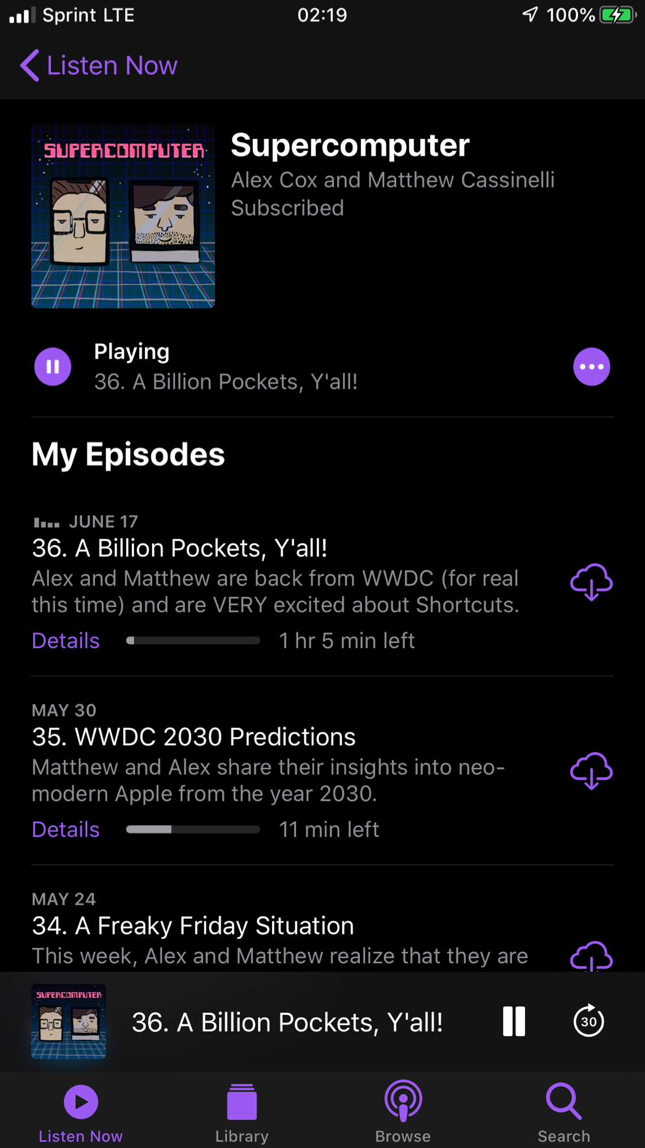

[Apple Podcasts in iOS Dark Mode](https://i.snap.as/Xmnxc4D.png)

* Install was both smoother and significantly faster than the last iOS Beta I partook in (probably 7.)
* Through my eyes at least, Dark Mode on my nearly 2-year-old iPhone 8 Plus did *not* leave a great impression.



[Slimmed Background App Location Use Banner](https://i.snap.as/lgUN78W.jpeg)

## Native Apps

* The **App Store**... where the *fuck* are my goddamned updates!!!
* I’ve been Uber/Lyft driving recently which involves serving live location data to *at least* three individual apps between rides. (When “online” for both services,
* **Are you kidding me.**

iOS supports the AVRCP 1.6 standard, which includes album art when connected to a supported car kit or speaker.

#### Definitely not an unreasonable priority at all.

* The ability to crop and rotate video comes *years* too late for me... I was made a casualty long ago...

Nearly everything you can do with a photo you can now do with a video. Adjustments, filters, and crop support video editing, so you can rotate, increase exposure, or even apply filters to your videos. Video editing supports all video formats captured on iPhone, including video in 4K at 60 fps and slo-mo in 1080p at 240fps.

* Apple’s native Notes app appears completely unchanged to me??? As in... it’s still immediately unusable because of its tacky-ass leather stucco-ish background texture.

### Apple Maps

* **MAPS... HOLY SHIT**
* [iOS 13: New iMessage Feature May Give Users Cause to Pivot From Google Maps | Inverse](https://www.inverse.com/article/57729-ios-13-apple-maps-google-maps)

#### [Typing ETA iMessage | Reddit](https://www.reddit.com/r/iOSBeta/comments/cct0th/feature_when_using_apple_maps_typing_eta_is_in/)

<blockquote class="reddit-card" data-card-created="1563356006"><a href="https://www.reddit.com/r/iOSBeta/comments/cct0th/feature_when_using_apple_maps_typing_eta_is_in/">[Feature] When using Apple Maps, typing “ETA is” in Messages will give the time to destination and arrival time.</a> from <a href="http://www.reddit.com/r/iOSBeta">r/iOSBeta</a></blockquote>

<script async src="//embed.redditmedia.com/widgets/platform.js" charset="UTF-8"></script>

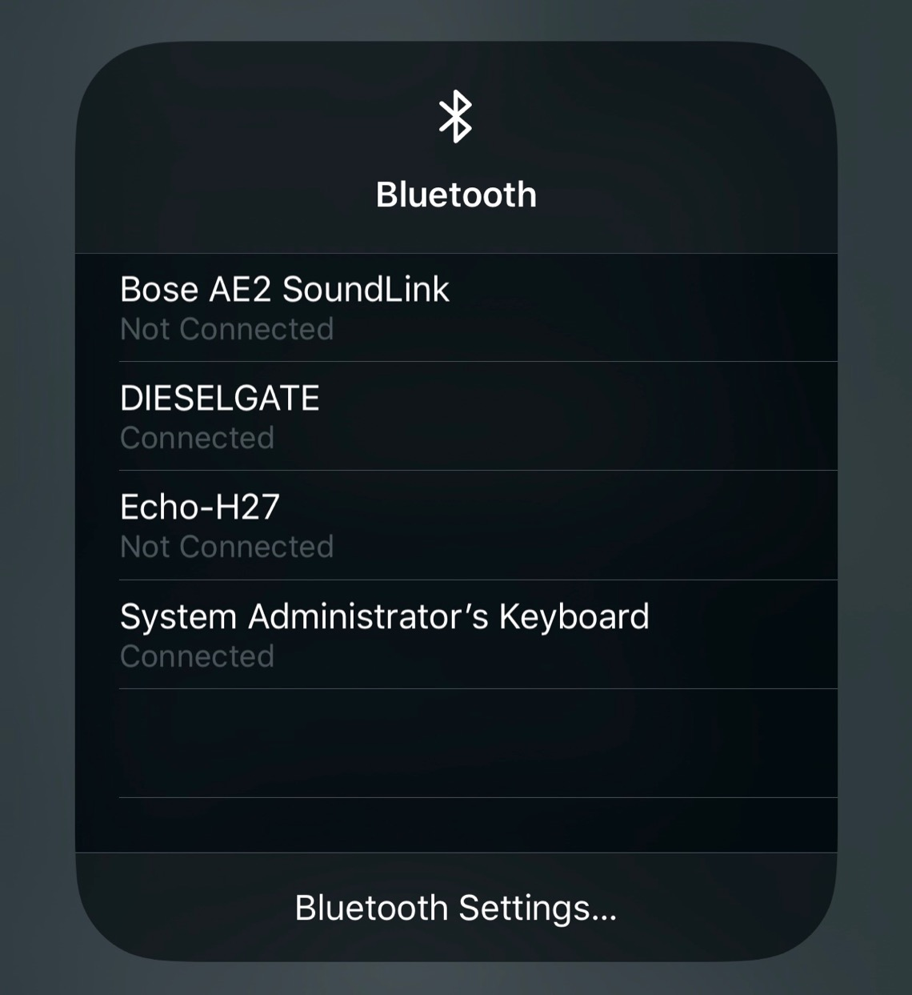

[iOS 13 Control Panel Bluetooth Options](https://i.snap.as/Zn36HXu.jpeg)

### Command Center

* Though it still drives me absolutely fucking bonkers that the team won’t just use 3D touch to allow users to fully disable bluetooth and/or wifi from the **Command Center** (or just utilize it more in general,) the new device/connection selection and shortcut to each protocol’s respective menu in Settings *are* positive steps in a sensible direction. I’m starting to suspect that Apple must surely have some sort of good practice standard which such a feature would violate because even [my own quick-disable shortcut](https://shortcutsgallery.com/shortcuts/turn-off-bluetooth-wifi/) has inexplicably ceased functioning in the past 6 months. :(

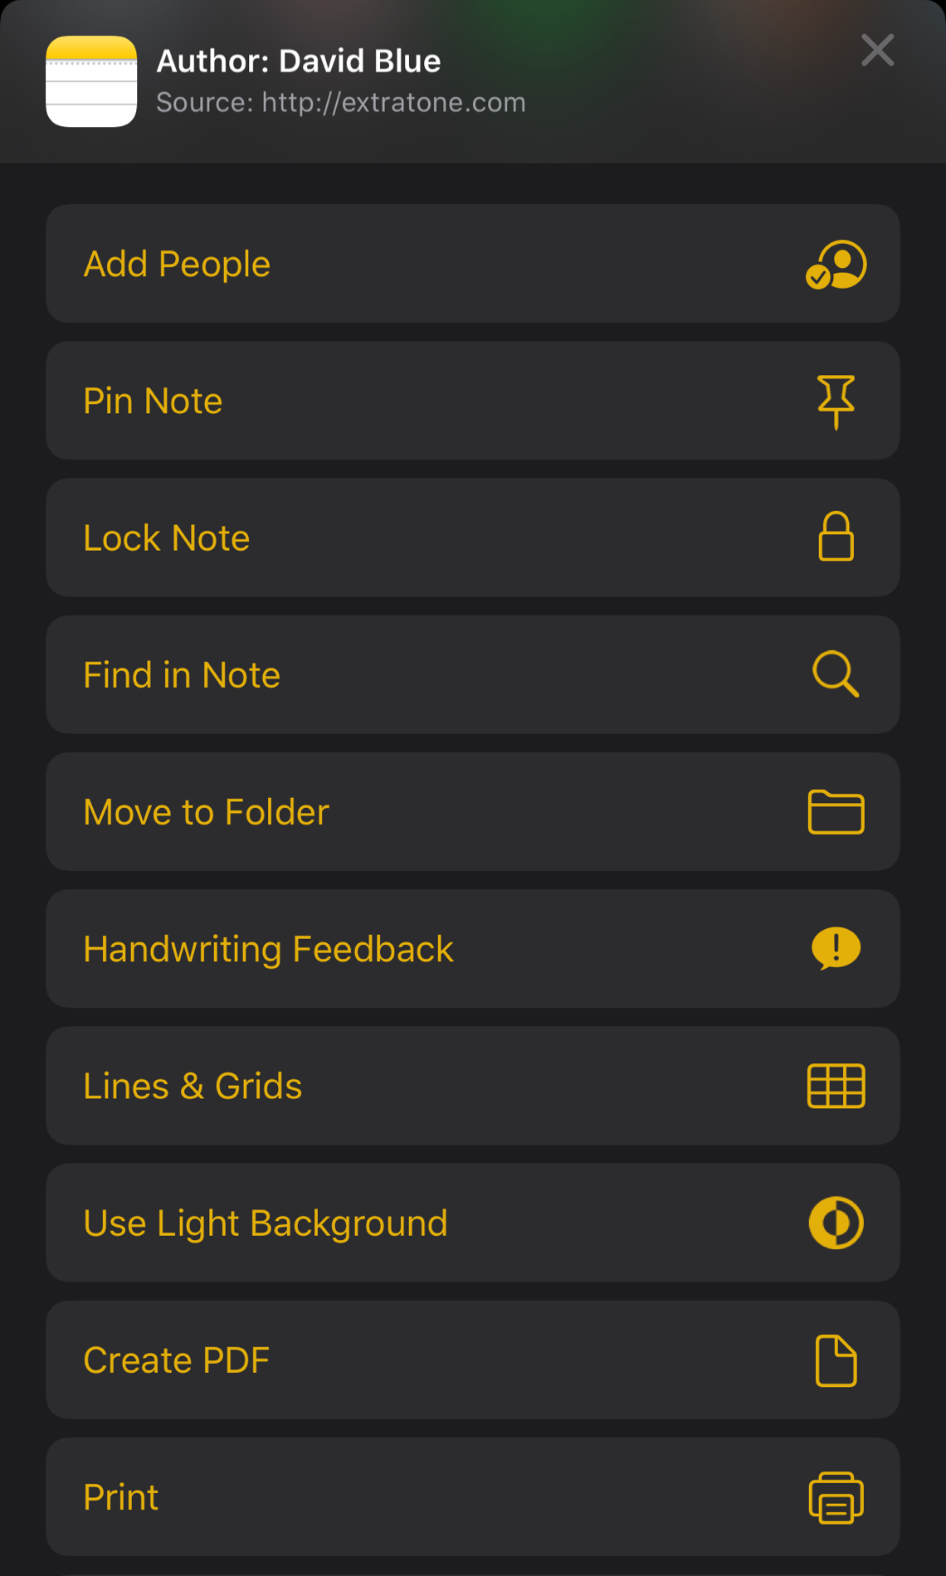

### Notes

#### Though I was just defending skeuomorphism, I have somehow managed to hate everything about the way iOS’ native Notes app has looked since the very beginning.

### Safari

#### I’m sad to say, is still far from the most effective browser available on iOS - I decided to swap it back in to slot #1 on my doc, replacing [Firefox](https://apps.apple.com/us/app/firefox-private-safe-browser/id989804926) for the duration of this experience.

#### In keeping with that comparison: [Firefox 12 for iOS](https://www.engadget.com/2018/06/12/firefox-12-ios-file-downloads-easier-syncing/) introduced a Downloads manager & folder, “unified link management,” and iCloud sync in February of last year, which left the native Safari at perhaps its lowest point of regard on iPhone. For most of us UX obsessives, it has only been launched in the time since by hyperlinks from the few good apps remaining which still do not offer a default preference to Chrome and/or Firefox. One would imagine, then, that the iOS Safari team has been under substantial internal pressure to deliver a miraculous rework/featureset bent on conquering the hearts of app critics and powerusers once again. Unfortunately, the version I’ve been subjecting myself to in iOS 13 Beta smells an awful lot like defeatism.

* Tab switching is still the smoothest-animated, but remains by far the slowest and most crashy of all the mainstream mobile browsers.
* Unfortunately, it’s quite pitiful when Apple *invents* features months/years after the *alternative* crowd mastered them *on the fringe* with zero disadvantages. There *are* some genuinely-clever additions like **saving open tabs as bookmarks**, and informed folks like *[Gadget Hacks](https://ios.gadgethacks.com/news/20-features-ios-13s-safari-you-wont-want-miss-0198425/)* who’ve described it as “formidable,” yet many of their citations invoke token Apple jokes. *Thank you so much, your majesties, for giving us this new gift of your genius... The Start Page*.
* The one ever-improving advantage of using native Safari which I think we can all agree on aligns with Apple’s new - and actually quite admirable - **privacy and security-founded brand identity**. (
* > A new downloads folder gives you a central place to access your web downloads and attachments from Safari and Mail.

### Siri

* Siri is my favorite voice assistant because she’s by far the biggest idiot of the bunch, yet I’ve found her to *actually* add real functionality to my experience.

## Keyboard Shortcuts

* The new “Quickpath” swiping keyboard makes zero sense as a feature add at this point, but okay Craig.
* Fucking **VALIDATED** by the attention to keyboard shortcuts (most of the big-deal PadOS’ new shortcuts seem to have been tossed in the iPhone too. God Bless.) Very nice of Craig Apple... I am the only iPhone user in history who has (and continues to) ever made use of this feature more than once. (I didn’t have a laptop in Community College so I just fooled around in Evernote, hunched over my little iPhone 4S to reach the fucking thing.)

#### *Specifically* though... I can’t find any direct mention of it in Apple’s current preview documentation, but Command-Space shows/hides **Spotlight**, which is the only way to switch between apps without the touchscreen (I can’t seem to find a definite answer on whether or not Command-Tab ever functionally switch applications on iPhone, but I think I would remember it.) This function has always been just clunky enough to interrupt a good workflow.

#### For instance, let’s say I needed to switch from this very document in Bear to YouTube in order to grab a hyperlink to a [quick demo capture](https://youtu.be/Yt5lPqn2i6M). Here’s what my keystrokes would look like:

Command Space y o u tab enter

#### ￼

* The various performance updates might seem like a bonus to some, but those of us who’ve been paying attention (out of need or curiosity) to the *absolutely absurd* size of regular app updates to date find the rework of software packages in iOS 13 (claimed 50% smaller App Store packages and 60% smaller updates) to be nothing more than a monstrously-late address to conclude *years* of gross negligence. (Remember we’re talking about the world’s richest company, here... There is no excuse for anything but perfection.)

## Files

<http://bit.ly/tratomedia>

## Text

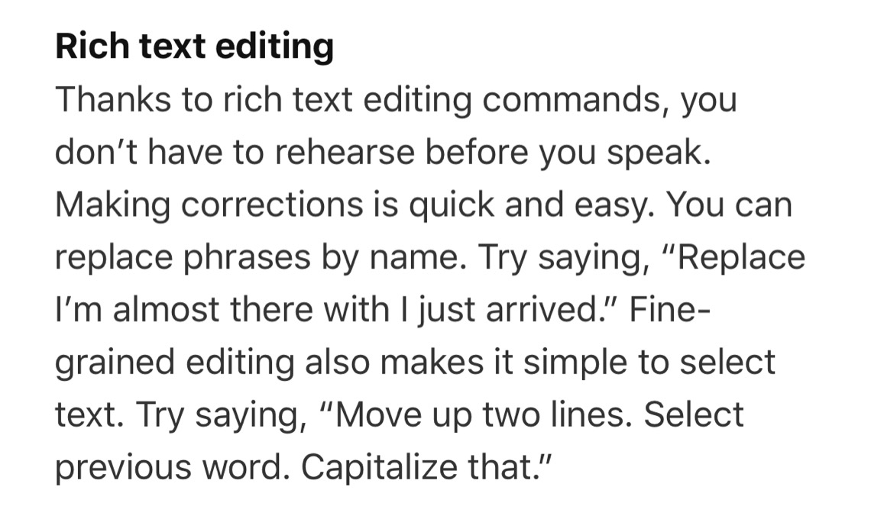

[Apple Bets on Rich Text](https://i.snap.as/COuYE0d.jpeg)

* Amazing. Revolutionary. Unfortunately, I am not quite dilligent enough to count how many times Rich Text was mentioned in the ~2.5 hour [WWDC 2019 keynote](https://youtu.be/UThGcWBIMpU)
* [iOS 13: You can soon install, manage and download custom fonts for your iPhone](https://www.cnet.com/news/ios-13-ipados-iphone-install-download-manage-custom-fonts-from-app-store-settings/) | *CNET*

## General UI

* Admittedly, it did not occur to me just how stale iOS’ audio/ringer volume indicator had become until I first hit a hardware button while running 13 and marveled at the newfound consideration of use exhibited by Apple’s placement of the new element where it belonged 12 years ago.

Apple is making it a lot easier to delete apps in iOS 13. Now, whenever you see a pending app update on the App Store (or have already downloaded and installed one), swipe left on the app. You’ll see the familiar red “Delete” button, which you can tap to remove the app from your iPhone or iPad.

#### -*[Lifehacker](https://lifehacker.com/the-best-ios-13-tricks-you-havent-tried-yet-1835838149)*

* Another reminder from me about 3D Touch for the hell of it, really: **it’s good.** It’s probably not worth depleting you of patience *entirely* and/or *existentially*, but you’re missing out on perhaps the most satisfying way to Touch Your Phone, if nothing else. I usually suggest practicing force-touching apps directly on the homescreen to prompt the quick function/share menu without fear of inordinate consequences
* I could be losing my mind, but I’m almost positive an twisting animation has been added when switching apps/returning to the homescreen.

[What's new in iOS 13 developer beta 4?](https://9to5mac.com/2019/07/17/whats-new-in-ios-13-developer-beta-4/) | *9to5Mac* What's new in iOS 13 developer beta 4?

#### #software